Theorem 1.1
On each side of a parallelogram erect a regular quadrangle, lying exterior to the parallelogram. Then the mid segments connecting the neighboring apices of the regular quadrangles themselves are the apices of another regular quadrangle.
Given a parallelogram ABCD. On its sides erect exterior regular quadrangles BEFC, CKPD, AMND, and MTQB.
Consider
O₁ – the midpoint of QE;
O₂– the midpoint of FK;
O₃– the midpoint of PN;
O₄– the midpoint of MT.
By turning around the point B at the angle of 90 ° counterclockwise vector $\vec{BC}$ the vector becomes $\vec{BE}$, and the $\vec{BQ}$ in $\vec{BA}$. Therefore the vector $\vec{CQ}$ goes into the vector $\vec{EA}$, that means |$\vec{CQ}$|=|$\vec{EA}$|, $\vec{CQ}$=$\vec{EA}$ и ∠($\vec{CQ;}\vec{EA}$) = 90º.
As H₁ is the point of intersection of the diagonals of the quadrangle BEFC, H₁ is the midpoint of EC and BF. Similarly, H₂ is the midpoint of DK and CP, H₃ is the midpoint of NA and MD, H₄ is the midpoint of QA and TB.
As О₁H₁ is the mean line of ΔQEC, then O₁H₁= $\frac{1}{2}$CQ и O₁H₁||CQ
As O₁H₄- is the mean lineof ΔAQE, then O₁H₄= $\frac{1}{2}$EA и O₁H₄||EA
Thus, O₁H₁= O₁H₄и O₁H₁$⊥$ О₁H₄.
Similarly, as H₁O₂ is the mean line of ΔBFK, then H₁О₂= $\frac{1}{2}$ BK и H₁О₂||BK

As ∠QBE=180°-∠ABC=180°- (180°-∠BCD) =∠BCD, то ∠QBC=∠BCK, therefore ΔBQC=ΔBCK (2 sides and the angle between them ), from the equality of thetriangles we get CQ=BK. As theopposite sides of the quadrangle QCKB are equal in pairs, then it is a parallelogram by idication.
As CQ||BK.
Then O₁H₁= H₁О₂ and O₁H₁|| H₁О₂. As O₁H₁ and H₁О₂ have a common point, they lie on one straight line.
Similarly, O₁O₄= 2O₁H₄ then points O₁, O₄, H₄ lie on one straight line.
As O₁H₁=O₁H₄, then O₁O₄=O₁O₂ and O₁O₄$⊥$O₁O₂.
Similarly we can prove for the other sides of the quadrangle, consequetly O₁O₂O₃O₄ is a square. Hence we obtain a proof for the theorem.
The same task can be solved by the coordinate method.
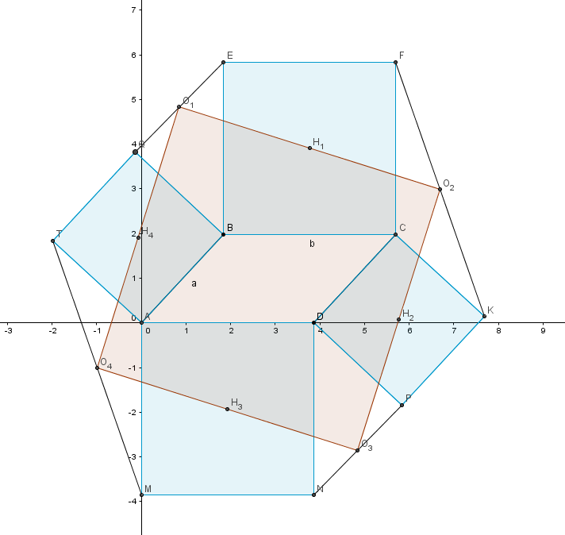
We introduce a rectangular coordinate system so as to coincide with the start point A, and the OX axis passes through the line BC. We find the coordinates of all the points in a given coordinate system

$$T\left(-a∙\sin{α};a∙\cos{α}\right);$$
$M\left(0;-b\right)$;
$B\left(a∙\cos{α};a∙\sin{α}\right)$;
$Q\left(a∙\cos{α}-a∙\sin{α};a∙\cos{α}+a∙\sin{α}\right)$;
$E\left(a∙\cos{α};a∙\sin{α}+b\right)$;
$$F\left(a∙\cos{α+b};a∙\sin{α}+b\right);$$
$K\left(a∙\cos{α+b}+a∙\sin{α};a∙\sin{α}-a∙\cos{α}\right)$;
$P\left(a∙\sin{α}+b;-a∙\cos{α}\right)$;
$N\left(b;-b\right)$;
$A\left(0;0\right)$;
$$O_{1}\left(\frac{2∙a∙\cos{α}-a∙\sin{α}}{2};\frac{2∙a∙\sin{α}+a∙\cos{α}+b}{2}\right)$$
$$O_{2}(\frac{2∙a∙\cos{α}+2b+a∙\sin{α}}{2};\frac{2∙a∙\sin{α}-a∙\cos{α}+b}{2})$$
$$O_{3}(\frac{2b+a∙\sin{α}}{2};-\frac{a∙\cos{α}+b}{2})$$
$$O_{4}(-\frac{a∙\sin{α}}{2};\frac{a∙\cos{α}-b}{2})$$
$$\vec{O_{1}O_{4}}(-a∙\cos{α};- a∙\sin{α}-b)$$
$$\vec{O_{1}O_{2}}(b+a∙\sin{α};-a∙\cos{α})$$
$|\vec{O_{1}O_{4}}|$=$\sqrt{{(-a∙\cos{α)}}^{2}+({-a∙\sin{α}-b)}^{2}}$
$$\left|\vec{O_{1}O_{2}}\right|=\sqrt{{(b+a∙\sin{α})}^{2}+{(-a∙\cos{α)}}^{2}}$$
$$We get \left|\vec{O_{1}O_{4}}\right|=\left|\vec{O_{1}O_{2}}\right|$$
The scalar product of the vectors $\vec{O_{1}O_{2}}∙\vec{O_{1}O_{4}}$ = 0, then the angle between them is 90 °.
Similarly we can prove for the other sides of the quadrangle, consequetly O₁O₂O₃O₄ is a square by definition. Hence we obtain a proof for the theorem

